**Simulation-8**

**Aim: Application of MATLAB to design first order and second order control systems**

**Software Required:**

* MATLAB SIMULINK

**First order control systems:**

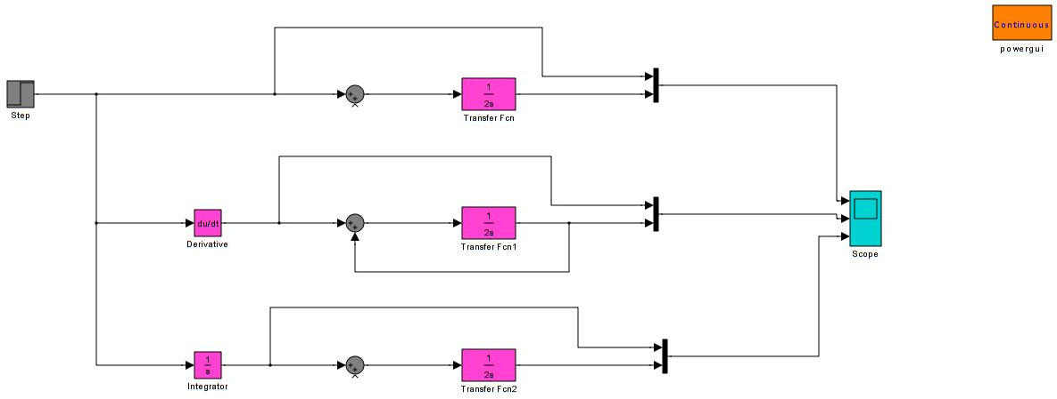

*Fig 1: SIMULINK circuit of first order control systems*

**Output waveforms obtained:**

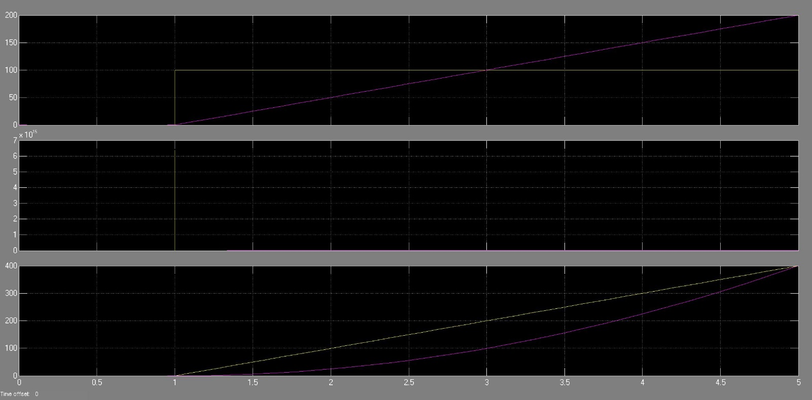

*Fig 2: SIMULINK output of First order control systems.*

**Second order control systems:**

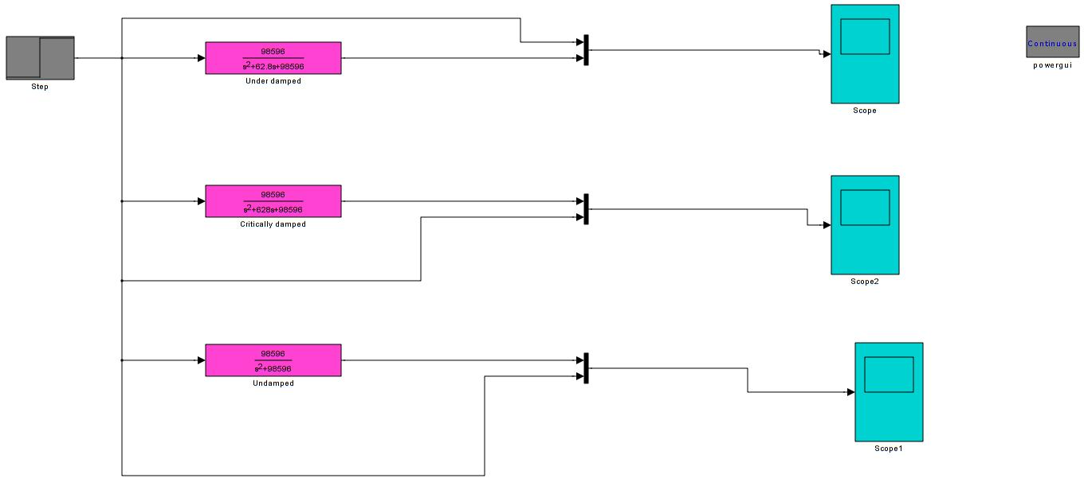

*Fig 3: SIMULINK circuit of second order control systems*

**Output waveforms obtained:**

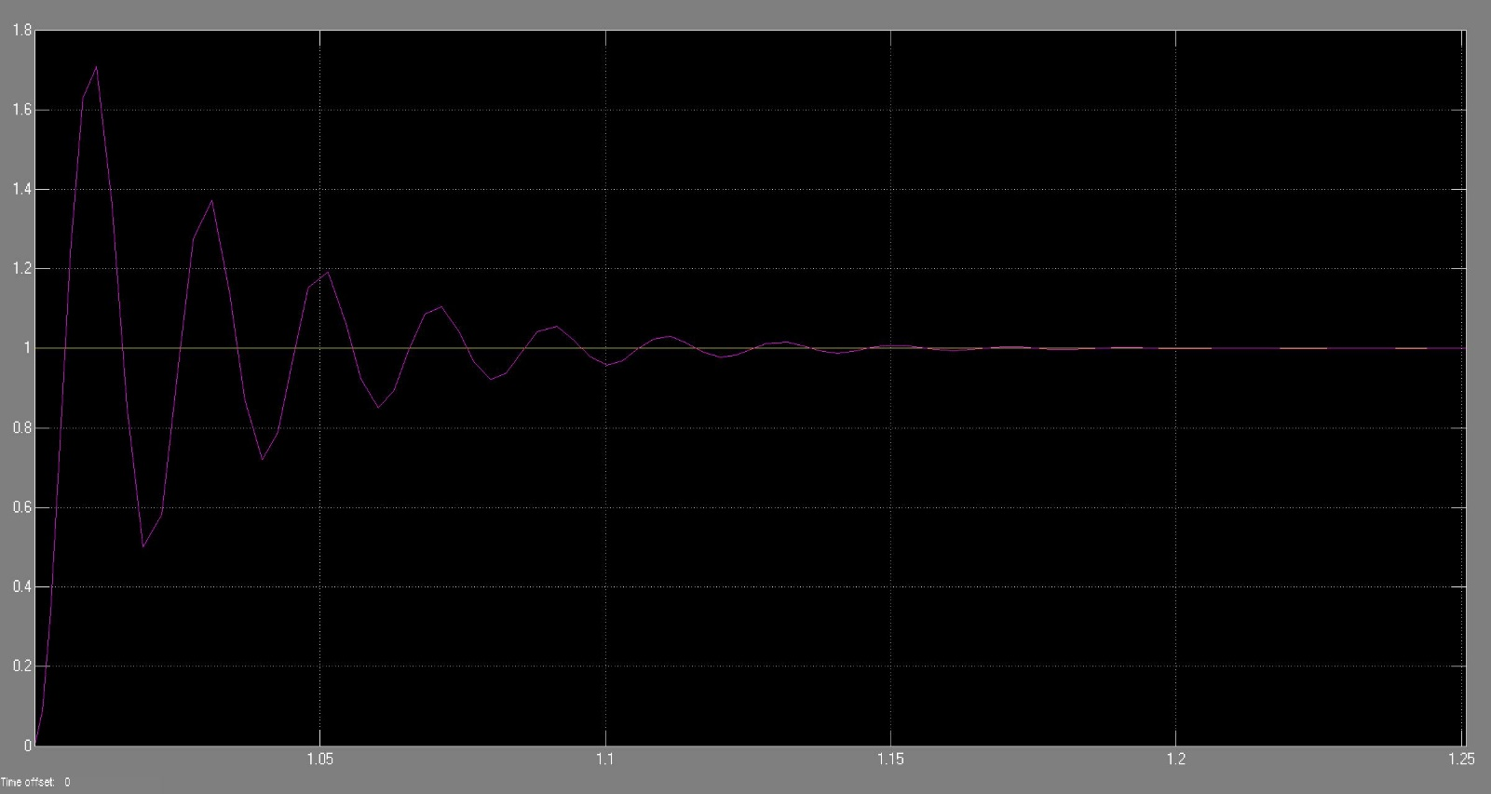

*Fig 4: SIMULINK output of second order under-damped control systems*

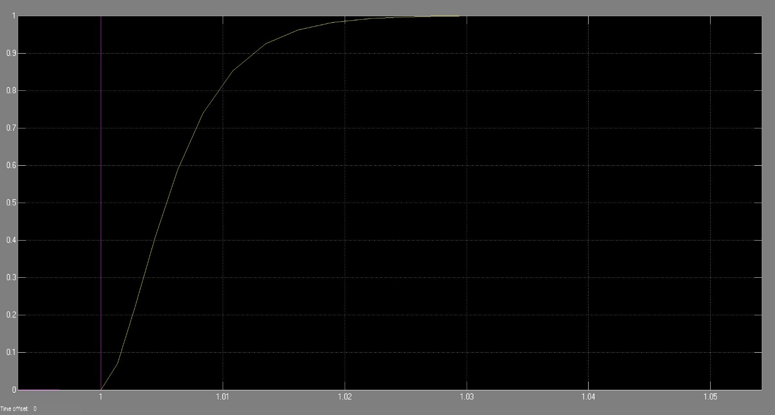

*Fig 5: SIMULINK output of second order critically-damped control systems*

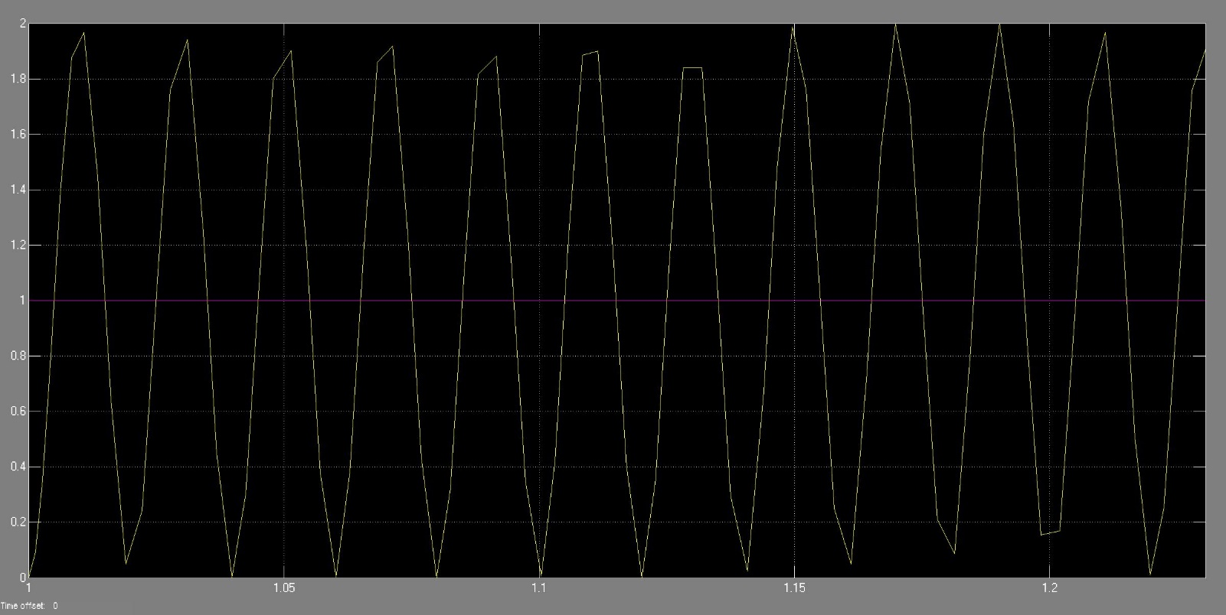

*Fig 6: SIMULINK output of second order undamped control systems.*

**RESULTS:** The outputs of first order control systems and second order control systems have been obtained.